In Your Arms Tonight

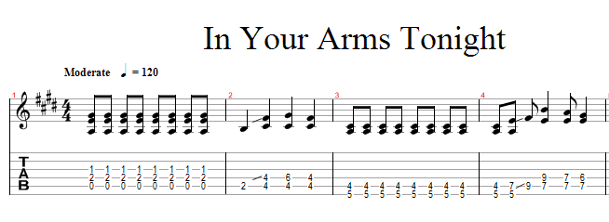

|  |  |
| --- | --- |
| E  Running head-on  A E  To things that knock me down  E  Over again  A  You picked me off the ground  E C#m A  And I wasn’t strong enough to fight  F#m A E  Anymore, but in your arms tonight.  A  Hold me close and tight  E  In your arms tonight  In your arms tonight  A  In your arms tonight  E A  Oh my love  God only knows  Why I don’t just retreat  ‘Stead of riding the rails  Back to the place of my worst defeat  ‘Cause I ‘m not fooling anyone, not quite  Convincing you  But when your arms are in mine  Try not to be strong  Cry ‘till it’s all gone  If you hold me tight  In your arms tonight  Oh my love  For years you’ve seen in me  The one who’d be there for you  The way I need you, here tonight  Yeah yeah yeah  In your arms tonight  In your arms tonight  In your arms tonight  Ooh in your arms ooh my love oh ya oh oh |  |